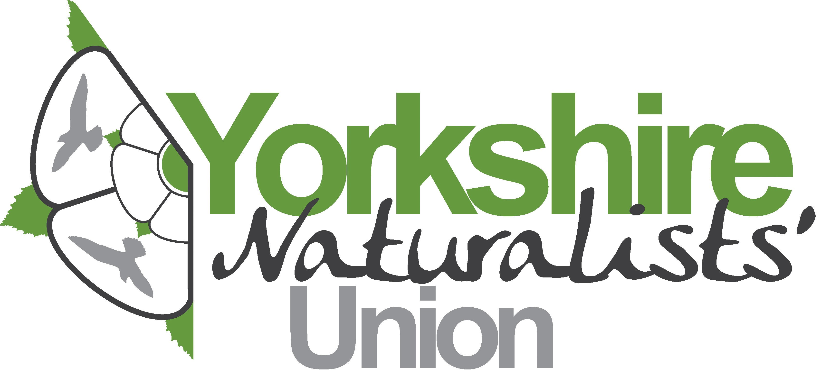

Membership Subscription Form

Registered Charity Number: 224018

Subscription Rates | First year (introductory offer) | Renewal
Individual membership | £15 | £25
Joint membership* | £20 | £30
Low income/unwaged/student | £5 | £15
* Two people at the same address
Subscription payments are due on the 1st January and should be sent to the Membership Secretary:
Clare Langrick, NEYEDC, Unit 7, Hassacarr Close, Dunnington, York, YO19 5SN
E- mail: membership@ynu.org.uk
Tel: 01904 641631

I / we wish to join / renew membership of the YNU
Title: | First name(s): | Surname:
Title: | First name(s): | Surname:
Address

Post code
Phone
E-mail
Membership type  (please circle | Individual Joint Low income / unwaged

I enclose a cheque for £ payable to Yorkshire Naturalists’ Union
I have paid £ by bank transfer to Yorkshire Naturalists’ Union
Account number: 86853953, Sort Code: 56-00-54
I have instructed my bank/building society to pay my subscriptions annually by Standing Order
GIFT AID: I confirm that I pay tax on my income, savings or pension and that the Yorkshire Naturalists’ Union may reclaim tax on my subscriptions paid on or after the date of this declaration. Please treat my subscription payment as a gift aid. | YES / NO

Signed: | Date:

